TV Draw $5.00 each or 3 for $10.00
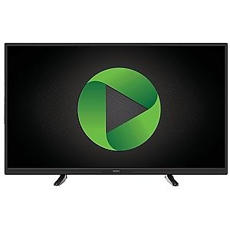
48 inch UHDTV

